**Pythakon Procedure:-**

* **Sequential procedure:-**
* **Flowchart:-**

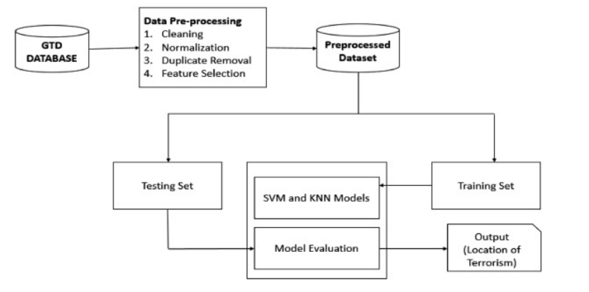

**Have to follow this flowchart.**

* **Steps:-**

**1)**

**Dataset:-**

**1)Exploring our dataset:-**

**Divide the dataset into two types-90% data for training and rest 2% for testing and validation.**

**Dataset:-**

**Training Testing**

**2)Building a 3)Accessing the**

**model model**